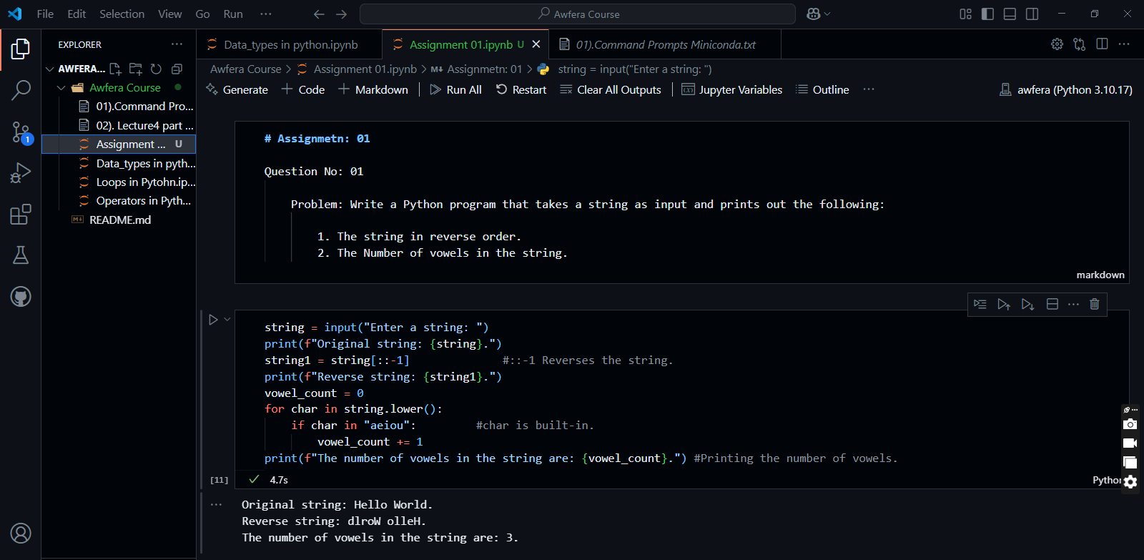**Question No: 01**

**Question No: 02**

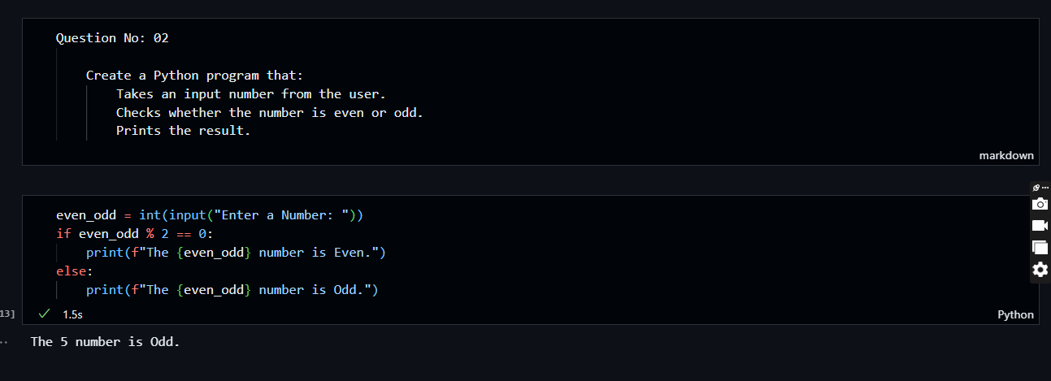

**Question No: 03**

**First create sortenv environment by using command 🡪 conda create –n sortenv python= 3.10 or 3.11 etc.**

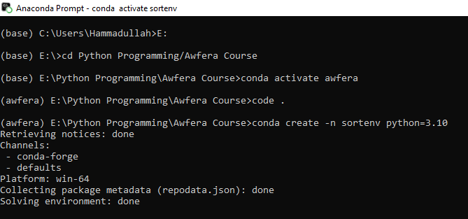

**Install numpy library**

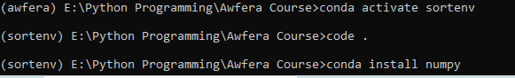

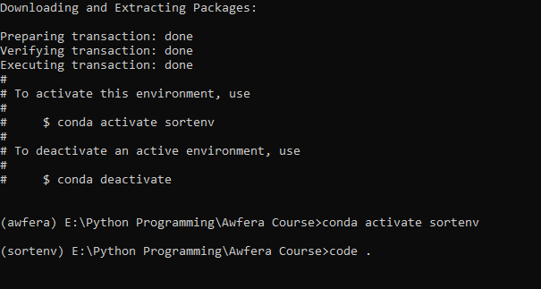**Then activate the environment and then code . press Enter button**

